PROJECT NAME: IT TICKET ANALYSIS

OBJECTIVE QUESTIONS

- What is the total no. of attributes present in the data?
Answer: The dataset contains a total of 29 attributes.
Formula : =COUNTA(TICKETS!A1:T1) + COUNTA('IT AGENTS'!A1:I1)
-The attributes were counted by summing the number of columns present in Sheet 1 (20 attributes) and sheet 2 (9 attributes).
Note: Additional derived columns (e.g., Age, Full Name, Domain) were created during analysis for better insights.

2. Which columns have inconsistent or missing values, and what is the count of such values?
Answer: After applying filters on all columns, no blank or missing values were identified in the dataset.Therefore, the count of missing values across all columns is zero.
-Upon reviewing the dataset, no inconsistent values were found within any column. Although certain labels may not follow standard terminology they are used consistently throughout the dataset.
- In the severity status it should be ‘major’ instead of ‘mayor’, ‘Unclassified’ instead of ‘Unclasified’, ‘Unassigned’ instead of ‘Unassiged’.
-Therefore, these are considered labeling or naming conventions not data inconsistencies.

3.What is the average daily ticket volume over time?
Answer: The average daily ticket volume over time is 53.37.
Formula : =average(‘OBJECTIVE ANSWER’ ! B3 : B1829).

4.What is the distribution of ticket categories (e.g., Login Access, System, Software)?
Answer: - I created a pivot table to find distribution of ticket categories with category as row and count of tickets as value along with a pie chart to visualise the distribution.
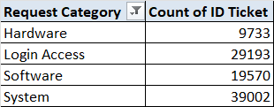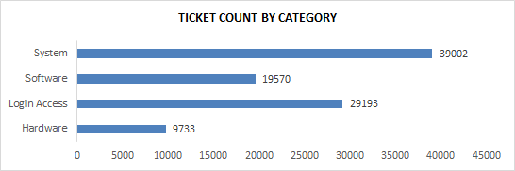

5.How many tickets has each agent handled?
Answer: The analysis shows that there are 50 unique agents and each agent has handled approximately 1900 to 2000 tickets.
- The number of tickets handled by each agent was calculated by grouping the data by Agent ID and counting the number of Ticket IDs associated with each agent.
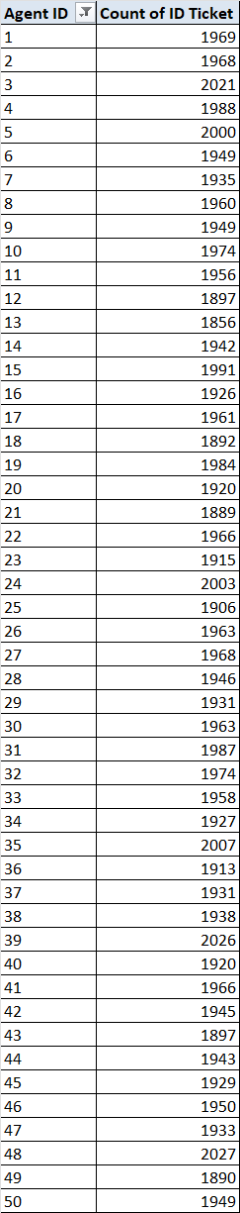

6.How can you extract the domain from the email addresses in the IT Agents sheet?
Answer:The domain was extracted from email addresses using the MID, FIND and LEN functions to capture the text after the “@” symbol in the IT AGENTS sheet.
- FORMULA: =MID(C2,FIND("@",C2)+1,LEN(C2)-FIND("@",C2)-4)
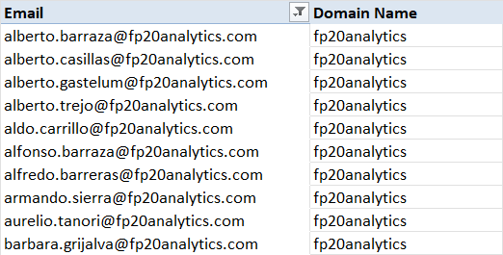
7.How can you find the full name of an agent given their Agent ID?
Answer: The full name of an agent is retrieved using a lookup function by matching the Agent ID from the tickets data with the Agent ID in the IT Agents sheet.
- FORMULA: =VLOOKUP(D2,’ITAgents’!A:B,2,FALSE)
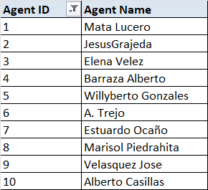
8.What is the count of each issue type (e.g., IT Error, IT Request)?
Answer: I created a pivot table with issue type as row and count of ticket as value.
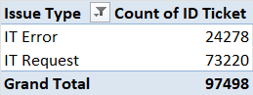

9.What is the daily average resolution time for tickets?
Answer: The daily average resolution time for tickets is 4.5 days.
Formula : =average(‘OBJECTIVE ANSWER’ !AN3:AN1829)
-Created pivot table with fecha(date) in rows and average resolution time in values.
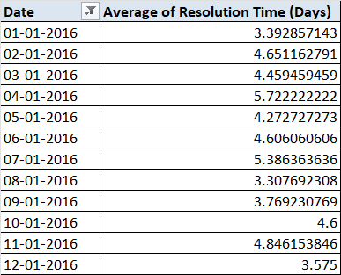
10.How has the volume of tickets changed over time?
Answer: The Column chart shows a consistent increase in ticket volume from 2016 to 2020 indicating a growing number of tickets over time.
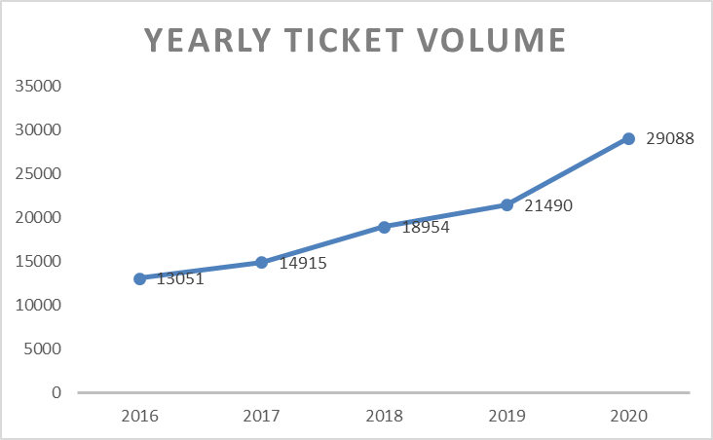
11.What is the average age of the IT agents?
Answer: The average age of IT agents is 40.46.
Formula : In sheet 2 (IT Agents)
- To calculate current age : =DATEDIF(DATE(D2,E2,F2),TODAY(),"Y")
- To calculate average of age : =average(‘OBJECTIVE ANSWER’ !BC3:BC53)
12.Is there a correlation between the severity of issues and the resolution time?
Answer: The correlation between severity and resolution time is -0.040536.
Formula : =CORREL(‘TICKETS’!Q:Q,’TICKETS’!K:K)
-To examine the relationship between issue severity and resolution time, severity number was first extracted from severity column to make it suitable for statistical analysis.
-The correlation was then calculated between the severity variable and the average resolution time using CORREL function.
-The result is -0.0405 which is very close to zero.
-This indicates no significant correlation between severity of issues and resolution time.
-Therefore, severity does not have a meaningful impact on how long tickets take to be resolved

13.How many categorical columns are there in the data?
Answer: There are 6 categorical columns that include:
- Request Category
- Issue Type
- Severity
- Priority
- Agent ID
- Employee ID

SUBJECTIVE QUESTIONS
1. If there is an investment, should it be used to hire more IT agents, improve training programs, or upgrade ticket management software? Analysis: Perform a cost-benefit analysis using ticket resolution and satisfaction metrics.
Answer: - Cost Benefit Analysis : Cost benefit analysis is a systematic process for evaluating the potential costs and benefits of a project, policy or decision to determine if the advantages outweigh the expenses.
The following metrics from the dataset are used:
-Average Ticket Resolution Time (Days) – operational efficiency
-Customer Satisfaction Score (Out of 5) – service quality
-Total Tickets and Agents – workload intensity
-Ticket Distribution by Category, Severity, Priority and Issue Type – operational complexity
Cost Benefit Analysis :

Option 1: Hire Additional Agents

COST | BENEFIT | RESULT
10 agents × ₹6,00,000 = ₹60,00,000 | -Approx 10% reduction in dissatisfaction = ₹15,00,000  -Marginal reduction in dissatisfaction | High recurring cost with limited long-term efficiency improvement.

Insights :
-Adding 10 agents increases workforce by 20% which can reduce workload per agent.
-Estimated 10% reduction in dissatisfaction but no major process improvement.
-Improvement depends heavily on manual effort not system efficiency.
-High recurring cost (salary every year).
Limitations :
-Does not solve root causes like priority handling or repeat tickets.
-Difficult to scale sustainably.

Option 2: Improve Training Programs

COST | BENEFIT | RESULT
50 agents × ₹20,000 = ₹10,00,000 | -5% reduction in repeat tickets = ₹24,00,000  -Better handling of tickets across severity and priority levels | -Satisfaction expected to improve from 4.1 to 4.3  -Better utilisation of existing workforce.

Insights :
-Training cost is relatively low compared to hiring.
-Reduces repeat tickets by 5% indicating better resolution.
-Improves agent confidence and standardization of responses.
-Moderate impact on employee satisfaction.
Limitations :
-Benefits depend on how well agents apply training.
-Does not significantly reduce resolution time without system support.

Option 3: Upgrade Ticket Management Software

COST | BENEFIT | RESULT
Software + implementation = ₹25,00,000 | -Productivity gain equivalent to 17 agents  -Cost avoided = 17 × ₹6,00,000 = ₹1,02,00,000  -Reduced dissatisfaction benefit = ₹36,50,000  -Total benefit = ₹1,38,50,000 | -Smart routing by category, severity, priority  -Faster handling of urgent and major tickets

Insights :
-One time investment with very high return.
-Smart routing by category, severity and priority directly addresses operational inefficiencies.
-Productivity gain equivalent to 17 agents without hiring.
-Faster handling of urgent and major tickets which strongly impacts satisfaction.
Limitations :
-High initial investment
-Agents need time to adapt to new system.
-System downtime or technical issues can disrupt operations.

Recommendation :
-Based on the cost benefit analysis, the initial investment should be made on improving training programs.
-While upgrading ticket management software provides high efficiency gains, improving training programs delivers a balanced combination of cost efficiency, workforce development and employee satisfaction making it the most appropriate investment choice at this stage.
-In the short term, training programs deliver cost effective improvements in employee satisfaction and service quality. However, in the long term, upgrading ticket management software becomes essential to sustain efficiency, scalability and high employee satisfaction as operational complexity increases.

2. Which agents need additional training based on their performance metrics?Analysis: Identify agents with the lowest satisfaction ratings and longest resolution times.
Approach : To identify agents who require additional training, an agent wise pivot table was created using Agent ID as the row field. Two performance metrics were considered:
- Average Resolution Time (Days)
- Average Satisfaction Rate
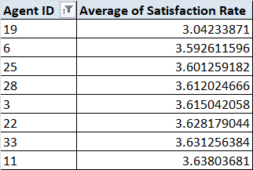
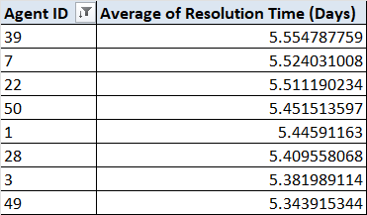

The overall average resolution time (4.55 days) and overall average satisfaction rating (4.10) were used as benchmarks. Agents showing higher than average resolution time along with lower than average satisfaction ratings were flagged for further review.

Agents with highest average resolution time (in days) :
- Agent 39
- Agent 7
- Agent 22
- Agent 50
- Agent 1
- Agent 28
- Agent 3
- Agent 49

Agents with lowest average satisfaction rate :
- Agent 19
- Agent 6
- Agent 25
- Agent 28
- Agent 3
- Agent 22
- Agent 33
- Agent 11

Insight : The analysis shows that these agents are likely facing challenges related to ticket handling efficiency, technical clarity or customer communication which is directly impacting customer experience.
Recommendation : It is recommended that the identified agents undergo targeted training programs focusing on:
- Faster and structured ticket resolution techniques
- Technical refresher sessions for complex issues
- Customer communication and soft skill improvement

3. Do certain categories of requests have longer resolution times?
Analysis: Analyze the resolution times by request category.
Approach : To analyze resolution time differences across request categories, a pivot table was created with Request Category as rows and Average Resolution Time (Days) as the value field. This helped in comparing how long different types of issues take to resolve on average.
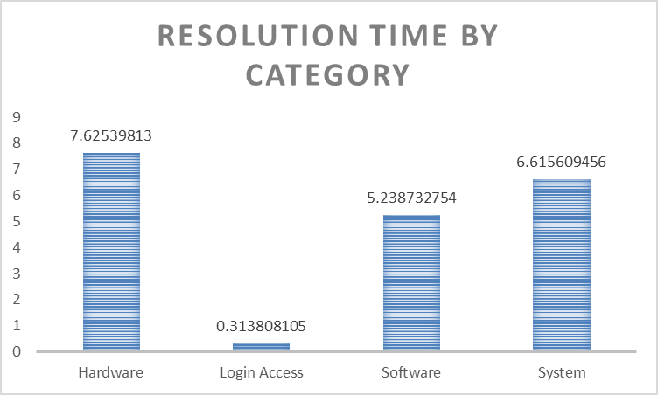

Insight : The analysis shows that resolution time is not uniform across request categories.
- Hardware requests have the longest average resolution time at approximately 7.63 days indicating higher complexity or dependency on physical resources.
- System related issues also take longer than average with an approximate resolution time of 6.62 days suggesting involvement of core system configurations.
- Software issues fall close to the overall average with a resolution time of around 5.24 days.
- Login Access requests are resolved the fastest with an average resolution time of just 0.31 days as these are generally straightforward and process-driven.
Recommendation : The significant variation in resolution times suggests a need for category specific improvements. Hardware and system related requests may benefit from better escalation processes, clearer documentation or specialized technical support. On the other hand, best practices from fast resolving categories like Login Access can be replicated to improve efficiency in other areas.

4. How effective are the current software tools in managing IT tickets?Analysis: Evaluate performance metrics before and after the implementation of new tools.
Approach : To evaluate the effectiveness of the current software tools used for IT ticket management performance was analyzed using pivot tables in Excel.
-Since the dataset does not explicitly mention the timeline of new tool implementation, effectiveness was assessed through operational indicators such as ticket volume handling, resolution efficiency, customer satisfaction, severity–priority alignment and year wise performance trends.
1. Ticket Volume & Resolution Efficiency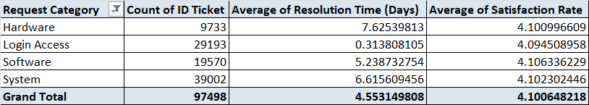
Insights:
-The system has handled a total of 97,498 tickets indicating strong scalability.
-The overall average resolution time is 4.55 days with an average satisfaction rate of 4.10 reflecting acceptable operational efficiency.
-Login Access requests are resolved very quickly (0.31 days) indicating strong automation and workflow efficiency.
-Hardware (7.62 days) and System (6.61 days) tickets take longer to resolve due to higher complexity.
-Despite longer resolution times, satisfaction remains consistently above 4 across all categories.

2. Severity vs Priority Analysis
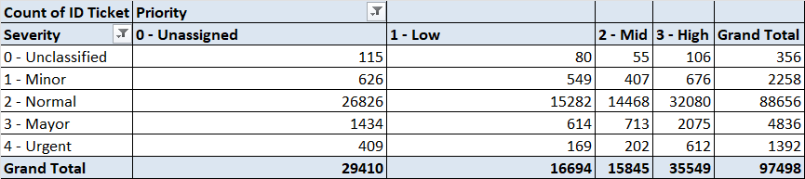
Insights:
-The severity-priority pivot table highlights misalignment in ticket classification:
-A significant number of Urgent and Major severity tickets are assigned Low or Unassigned priorities.
-For example, out of 1392 urgent tickets only 612 are marked as high priority.
-Such mismatches indicate limitations in rule based prioritization or manual dependency rather than resolution capability.
-This suggests that while the tool resolves tickets effectively priority assignment logic needs optimization.

3. Year wise Trend Analysis (2016-2020)
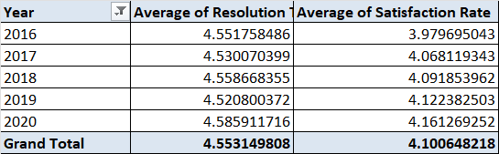

Insights:
-Average resolution time remains stable around 4.5 days across years.
-Customer satisfaction shows a gradual improvement rising from 3.97 in 2016 to 4.16 in 2020.
-This indicates consistent system performance and improving user experience over time driven by operational maturity rather than major tool changes.

Data Limitation Statement
-The dataset does not explicitly specify the timeline or indicators for the implementation of new software tools. Therefore, a direct before and after comparison is not feasible.
Recommendations :
-The current software tools are moderately effective in managing IT tickets.
-They demonstrate strong scalability, consistent resolution times and positive customer satisfaction. -However, effectiveness is constrained by priority–severity misalignment which can delay critical issue resolution.
-Rather than replacing the tools, improvements should focus on:
-Enhancing automated severity based priority rules
-Improving escalation workflows for urgent tickets
-Reducing manual dependency in ticket classification
-Overall, the tools support efficient ticket management but targeted process and configuration improvements are required to achieve higher operational effectiveness.

5. How has the performance of the IT support team changed over time (e.g., monthly or quarterly)?Analysis: Trend analysis using time series charts.
Approach : To understand how the IT support team’s performance has changed over time I carried out a year wise and month wise trend analysis using Excel. Created a line chart to compare how both metrics behaved over time.

Key Metrics :
- Average Resolution Time (in days)
- Average Satisfaction Rate
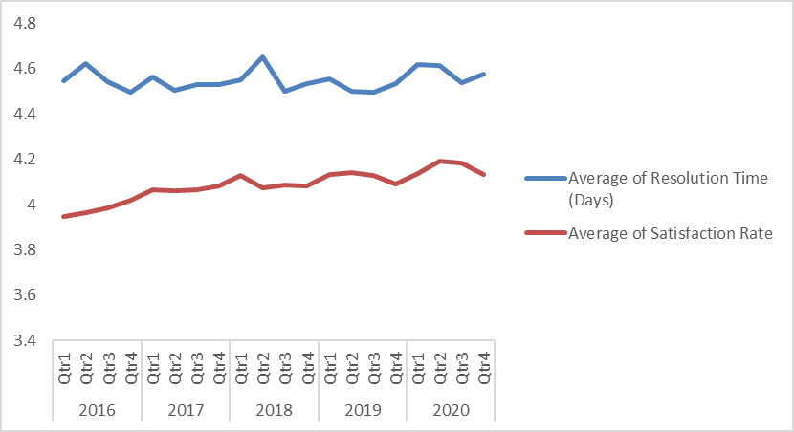

Insights : Based on the analysis of the data from 2016 to 2020, the following insights were observed:
- The average resolution time remains relatively stable generally ranging between 4.4 to 4.9 days indicating consistent ticket handling efficiency.
- A slight increase in resolution time is noticeable during certain periods which may be linked to higher ticket volume or complex issues.
- The average satisfaction rate shows a gradual improvement over time moving closer to the 4.1–4.2 range in later years.
- In periods where resolution time slightly increased, the satisfaction rate either stabilized or improved marginally suggesting that quality of resolution may have compensated for delays.
- Overall, the IT support team shows steady and controlled performance rather than sharp fluctuations indicating operational stability
- This trend suggests that the support team has maintained consistent service levels while gradually improving customer satisfaction.
Recommendation : Based on the observed trends, the following recommendations can be made:
- Continue monitoring resolution time closely during peak workload months to prevent service delays.
- Identify periods with higher resolution time and evaluate staffing or process improvements.
- Since satisfaction rates are improving, best practices used during high-satisfaction periods should be standardized.
- Use historical performance trends to forecast future support requirements and improve planning.
- Regular trend analysis should be maintained to ensure long-term service quality and efficiency.

6. If we invest more on tech (Hardware, software, etc), do you think it will improve the ticket resolution times and employee satisfaction?Analysis: Use historical data to project potential improvements.
Approach : To evaluate whether increased investment in technology could improve ticket resolution time and employee satisfaction I used historical performance data as a proxy.
The analysis compares:
-Category-wise ticket volume
-Category-wise average resolution time
-Category-wise satisfaction score
-Year-wise growth in ticket volume
Categories showing faster resolution and higher satisfaction are assumed to be supported by better tools, automation or systems. These patterns are then used to project the potential impact of increased technology investment.

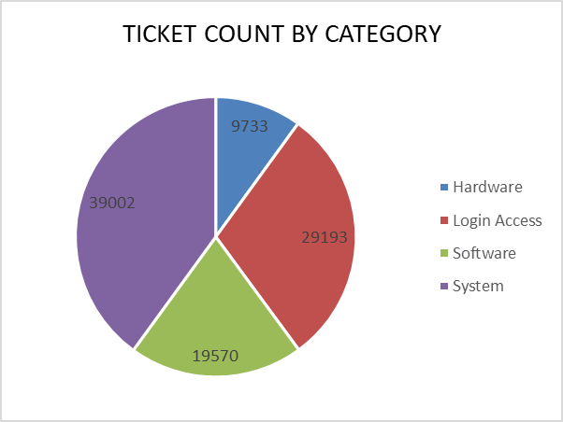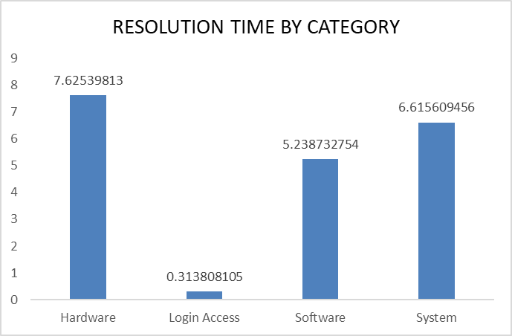
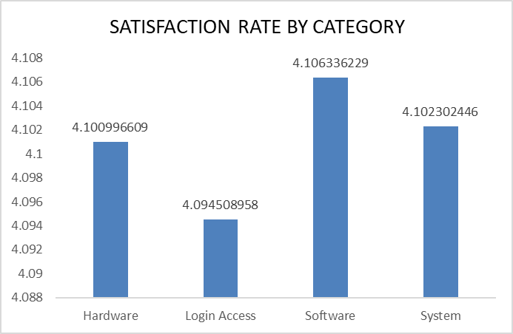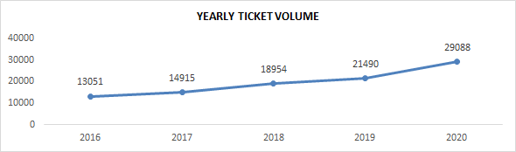

Insights : From the historical data analysis, the following insights were observed:
-Login Access tickets are resolved extremely quickly suggesting strong automation and efficient tools.
-Hardware and System tickets take significantly longer likely due to manual processes, legacy infrastructure or limited diagnostic tools.
-Despite longer resolution times, satisfaction remains relatively stable indicating users may accept delays for complex issues but this may not scale well as ticket volume grows.
-The consistent rise in ticket volume over the years implies that existing systems will face increasing pressure if not upgraded.
Recommendations : Based on the analysis and projections:
-Investment should be prioritized toward hardware diagnostics, system monitoring tools and software automation as these categories show the highest resolution delays.
-Expanding automation similar to Login Access workflows can significantly reduce resolution time for repetitive system and software issues.
-Upgrading ticket management software with better categorization, routing and escalation logic can improve efficiency without increasing headcount.
-Overall, targeted technology investment is likely to reduce resolution time and sustain satisfaction levels especially as ticket volumes continue to grow.

7. What are the key performance metrics for IT agents, and how can they be improved, do we need to fire any agents?Analysis: Define and analyze metrics such as average handling time,satisfaction scores and number of tickets resolved.
Approach : To evaluate IT agent performance I focused on measurable, objective metrics that directly reflect both efficiency and service quality.
The following metrics were used:
- Average Handling / Resolution Time – to measure efficiency
- Average Satisfaction Score – to measure service quality
- Number of Tickets Resolved – to measure workload handling and productivity
Key Performance Metrics :
1. Average Resolution Time : Indicates how quickly an agent resolves tickets.
- Higher values may point to:
- Skill gaps
- Complex ticket handling
- Tool or process inefficiencies
2. Satisfaction Score : Reflects end user experience and communication quality
- Low scores may result from:
- Delayed responses
- Poor issue explanation
- Incomplete resolutions
3. Number of Tickets Resolved : Measures workload handling capacity
- Very low counts may indicate:
- Inefficiency
- Over dependence on escalation



Insights :
- Some agents show higher resolution times along with comparatively lower satisfaction scores indicating scope for improvement.
- Some agents demonstrate efficient resolution times with high satisfaction scores. These agents can be treated as benchmarks for training and process improvement.

Do We Need to Fire Any Agents?
No, firing is not recommended based on this data.
Reasons:
- No agent shows extremely poor performance across all metrics.
- Most underperforming cases show skill or process gaps not negligence.
- Many agents with high resolution times still maintain good satisfaction indicating effort and quality.
When Firing Might Be Considered :
-Metrics are consistently and significantly below team averages and agreed upon standards even after training and coaching.
-If the agent shows no sustained improvement despite receiving targeted training.
Recommendations :
For Agents with High Resolution Time :
- Advanced technical training
- Better diagnostic and automation tools
- Knowledge sharing from top performing agents
For Agents with Low Satisfaction :
- Communication and customer handling training
- Clear resolution explanations
- Standard response frameworks
Overall Improvements :
- Match complex tickets with experienced agents
- Set performance benchmarks instead of penalties
- Track improvement through monthly dashboards

8. How do employee demographics (e.g., department, seniority) impact satisfaction and ticket outcomes?Analysis: Segment analysis using filters and pivot tables.
Approach : The analysis was conducted using pivot tables to segment data by age group and seniority. Key performance indicators such as average satisfaction rate and average resolution time and request category were compared across these segments to understand how demographics and departments influence ticket outcomes.
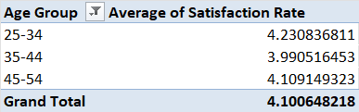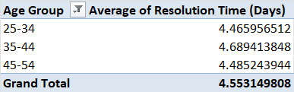

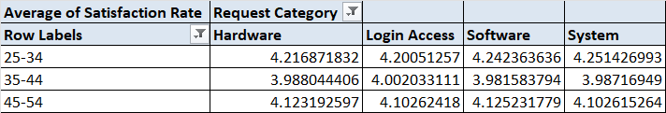

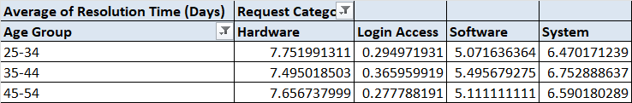
Insights :
Age Group Analysis :
- Agents in the 25–34 age group have the highest average satisfaction rate (≈ 4.23) and a relatively lower resolution time (≈ 4.47 days).
- The 35–44 age group shows the lowest satisfaction rate (≈ 3.99), even though their resolution time is comparable.
- Agents aged 45–54 have satisfaction levels close to the overall average but their resolution time is slightly higher than younger users.
- This indicates that mid career agents (35–44) may have higher expectations which impacts satisfaction levels.
Request Category (Department) Analysis :
- Login Access requests have the lowest resolution time (≈ 0.31 days) and a high satisfaction rate indicating efficient handling.
- Hardware requests take the longest to resolve (≈ 7.63 days) though satisfaction remains reasonably high.
- System related issues also have higher resolution times (≈ 6.62 days) reflecting their complexity.
- Software issues fall near the overall average for both satisfaction and resolution time.
Recommendations :
- Support strategies should be tailored based on user demographics and issue type.
- Priority handling and clearer communication should be provided for complex categories like hardware and system issues to manage expectations.
- Additionally, targeted feedback mechanisms for the 35–44 age group could help identify specific concerns and improve satisfaction levels.

9. Identify the trends for IT support operations based on ticket volumes and satisfaction, and mention the peak and stable times?Analysis: Use pivot tables and charts to identify peak and off-peak hours.
Approach : To identify trends in IT support operations, pivot tables were created using year-wise ticket data. Two key analyses were performed:
- Ticket Volume Trend Over Time – Using a pivot table showing the count of tickets per year per month visualized through a line chart.
- Satisfaction Trend Over Time – Using a pivot table showing the average satisfaction rate per year per month visualized through a line chart.
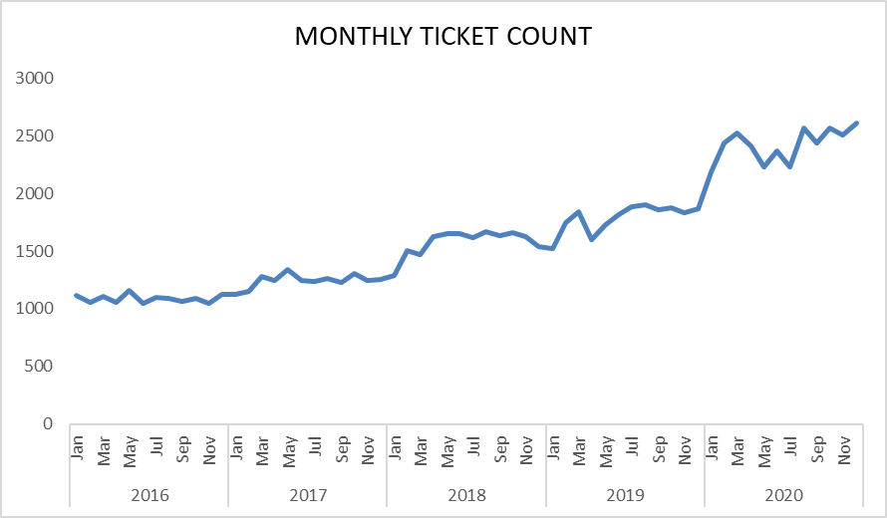
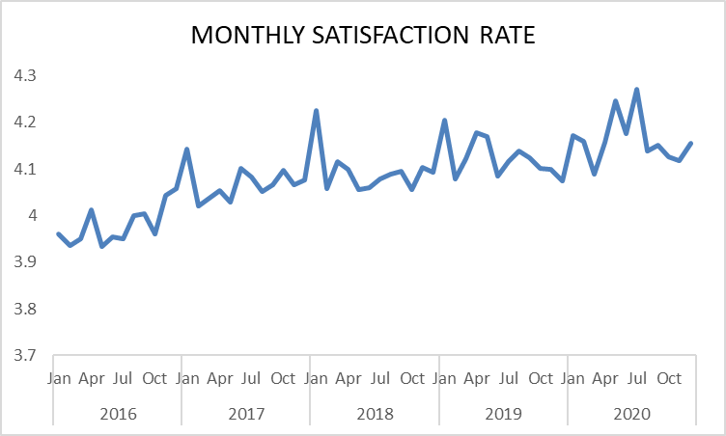

Insights :
Ticket Volume Trend :
- Ticket volumes show a consistent increase from 2016 to 2020.
- The highest ticket volume is observed in 2020 indicating peak operational demand.
- The lowest ticket volume appears in 2016 representing an early or stable phase of operations.
- The steady upward trend suggests growing dependency on IT support services over the years.
Satisfaction Rate Trend :
- Satisfaction rate improves gradually from 2016 onwards.
- A noticeable increase is observed after 2017 indicating improvements in service delivery or process efficiency.
- The highest satisfaction levels are seen in 2019–2020 despite higher ticket volumes.
- This indicates that the IT support team managed increased workload without negatively impacting user satisfaction.
Peak and Stable Periods :
Peak period : 2020, as it has the highest ticket volume while maintaining high satisfaction.
Stable period : 2016–2017, where ticket volumes were lower and satisfaction levels were relatively steady.
Recommendations :
- Since ticket volumes are increasing every year resource planning and staffing should be scaled accordingly.
- The improvement in satisfaction despite higher ticket volumes suggests that existing processes and tools are effective and should be strengthened further.
- Best practices from 2019–2020 should be documented and standardized to maintain service quality during peak demand.
- For deeper peak and off-peak analysis, future data collection should include ticket creation time (hours) to allow hourly workload optimization.
NOTE : The dataset does not include time-of-day information. Therefore, peak and off-peak hours could not be analyzed. The analysis is based on year-wise trends which still provide meaningful insights into operational growth and performance consistency.

10.What metrics should be included in the final dashboard to provide a comprehensive view of call center performance and guide investment decisions?
Approach : To design a comprehensive dashboard the focus should be on metrics that capture workload, efficiency, service quality.
The following metrics are derived from the available ticket, agent, priority, resolution time and satisfaction data and are visualized using KPIs, pivot tables and charts.
These metrics together help management monitor performance and make informed decisions regarding process improvement, staffing, training and technology investments.
Key Metrics to Include in the Dashboard :
1. Ticket Volume Metrics
- Total number of tickets
- Tickets by year / category / priority
Purpose: Helps identify workload trends, peak periods and areas generating the highest demand.

2. Resolution Time Metrics
- Average resolution time
- Resolution time by priority and request category
Purpose: Highlights efficiency levels and identifies bottlenecks where delays are frequent.

3. Customer Satisfaction Metrics
- Average satisfaction rate
- Satisfaction by year, priority and category
Purpose: Measures service quality and user experience especially under increasing workloads.

4. Agent Performance Metrics
- Tickets handled per agent
- Average resolution time per agent
- Average satisfaction score per agent
Purpose: Helps identify high performing agents and those who may require additional training or support.

5. Trend & Time Based Metrics
- Year wise ticket volume trend
- Year wise satisfaction trend
Purpose: Supports long term planning and helps evaluate whether performance is improving over time.

-The dashboard should include slicers for choosing the the specific data to make it more user friendly for management discussions and decisions.

